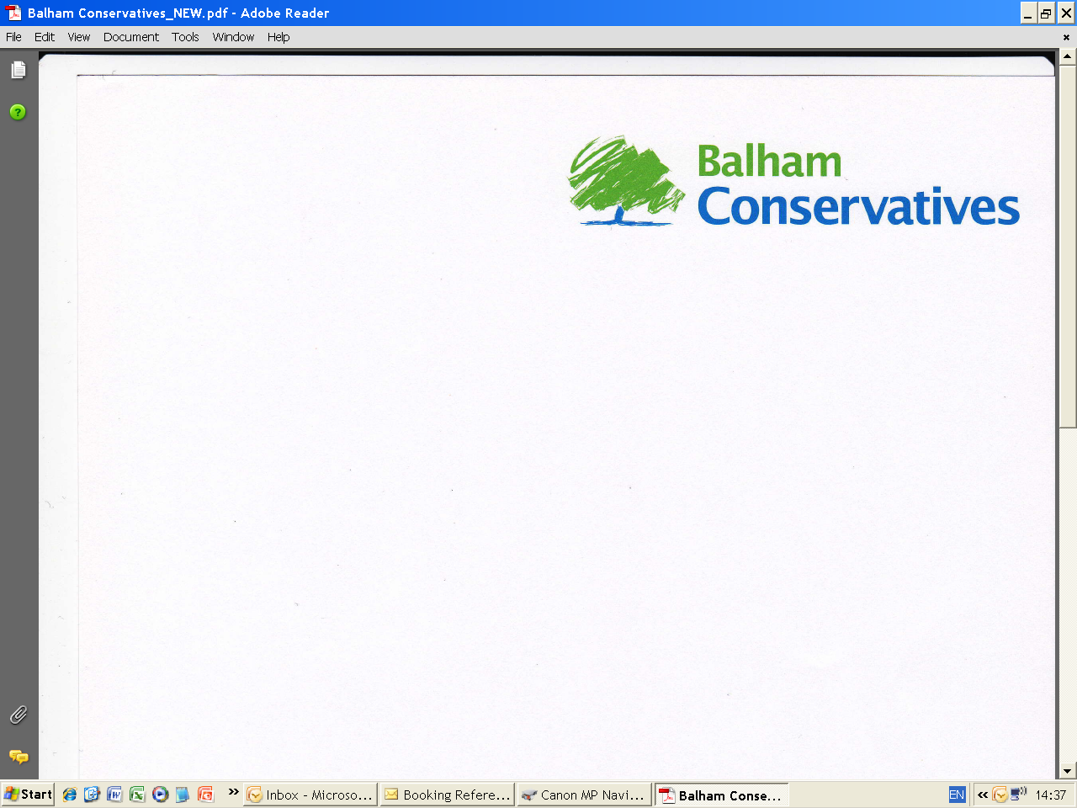

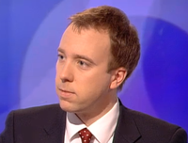
SPRING SOCIAL EVENING
Wednesday, 19th June 2013
Speaker: Matthew Hancock, MP
Minister for Skills

Broomwood Hall, 74 Nightingale Lane, Balham, London, SW12 8NR
7.00 pm – 9.00 pm

“HOW TO WIN THE NEXT GENERAL ELECTION”

Matthew Hancock was elected Member of Parliament for West Suffolk at the general election in May 2010. Since September 2012 he has been Minister for Skills (a joint post between the Department for Business, Innovation and Skills and the Department of Education).

Matthew holds a degree in Philosophy Politics and Economics from Oxford and a Master’s Degree in Economics from Cambridge. His first job was with his family computer software business. Later, he worked as an economist at the Bank of England and in 2005 moved to work for the then Shadow Chancellor of the Exchequer, George Osborne. On winning the West Suffolk seat, Matthew was elected to the Public Accounts Committee and appointed to the Standards & Privileges Committee. In September 2012 he became Minister for Skills where he is responsible for apprenticeships, Sixth Forms and Further Education, working in the Department for Business, Innovation and Skills and the Department of Education.

Matthew is married with two young children, and a keen cricketer. In 2011 he co-authored “Masters of Nothing” with fellow new MP, Nadhim Zahawi. The book explores the human behaviour that caused the financial crash and the changes needed to ensure it doesn’t happen again.

The theme of Matthew’s talk will be “How to win the next Election”. A question that must be a burning issue for all concerned and a topic of keen interest.

Please complete and return the attached form together with your cheque made payable to:
“Battersea Conservative Association” to: Nellie Zdraveska, 1 Blandfield Road, Balham SW12 8BQ.
..........................................................................................................................................................................................................................
Balham Conservatives Spring Social Evening –Thursday 23 May, 2013, from 7.00 pm – 9.00 pm.
Broomwood Hall, 74 Nightingale Lane, Balham, London, SW12 8NR.

I enclose a cheque for £………….…..for…………….…… places @ £17.50 each.

(Please Print):
Name(s):…………………………..………………………………………………………….……………………………………….……………………………………......................
Address:…………………………………………………………………………………………………………………………………………………………………………………….
Telephone:……………………………………........................................................... Mobile:…………………………………………………………..…………………………
Email: …………………………..……………………………………………………………………………………………………………………………………………………………
Name(s) of guest(s):……………………………………………………………………………………………………………………………………………………………………

